Knowledge Blueprint Documentation

1-Knowledge Template

Knowledge Base

✅ What does "Knowledge Template" mean?
# Source: AI Source: Provided by: [Data Path: Persons Table -> ID Column: 1, Name_En Column: Motasem Essam] -> From: [ChatGPT] on [7/14/2025]
A Knowledge Template is a predefined structure or framework designed to organize, capture, and present knowledge consistently.
It acts as a blueprint for knowledge, ensuring that information is stored or shared in a standard, structured way.

Rules and Guidelines

1-Knowledge Sources
# Source: AI Source: Provided by: [Data Path: Persons Table -> ID Column: 1, Name_En Column: Motasem Essam] -> From: [ChatGPT] on [7/14/2025]
- 1-Learning Source
- 2-Academic Source
- 3-Wiki Source
- 4-Multi Sources
- 5-My Source

- Learning Source:
A source designed to teach or explain a topic in a structured and easy-to-understand way. Examples include tutorials, online courses, training videos, educational blogs, and books. It often serves as a primary learning resource for understanding a subject.
- Academic Source:
A source that is formal and reliable, usually provided by schools, universities, or educational groups. Examples include school textbooks, university materials, official educational guides, and materials from educational organizations or learning groups.
- Wiki Source:
A source that is collaboratively written and edited by multiple contributors. It is useful for general overviews and summaries but may require verification. Example: Wikipedia.
- Multi Sources:
A source that combines information from multiple references to provide a broader perspective. Examples include aggregated reports, meta-analyses, curated content from books, articles, videos, and other online sources.
- My Source:
A source that is personal or self-created, such as your own notes, observations, experiments, or compiled knowledge. It can also integrate information from other references, including books, videos, online content, schools, educational groups, and curated sources, to produce original insights based on your own experience.

Example
# Source: ScreenShots (using Lightshot Program) From [Operating System: Widnows: File Explorer] Provided by [Data Path: Entities Folder -> Entities Database -> Persons Table -> ID Column: 1, Name_En Column: Motasem Essam] on [7/14/2025]
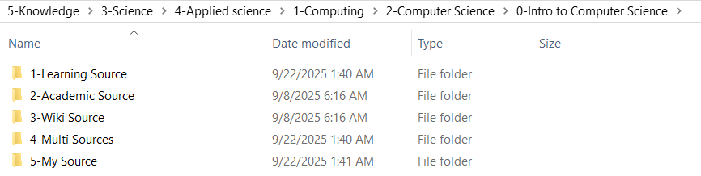

2-Record Source
# Source: Person Source: Provided by: [Data Path: Persons Table -> ID Column: 1, Name_En Column: Motasem Essam] Written by: [Data Path: Persons Table -> ID Column: 1, Name_En Column: Motasem Essam] on [7/14/2025]
Main source type: Main file -> at - [poisiton of file] at date: [Starting words....]
or
Main source type at date: [Starting words....]

Knowledge Template Breaks
# Source: Person Source: Provided by: [Data Path: Persons Table -> ID Column: 1, Name_En Column: Motasem Essam] Written by: [Data Path: Persons Table -> ID Column: 1, Name_En Column: Motasem Essam] on [7/14/2025]
1- Main source
required - {style is normal or bold, 11px, and hyperlink}
-:is main folder whci is type [like: Multi sources, Chatgpt (GPT-4-turbo), Wiki source, ...]
2- Main File
required - {style is normal, 11px, and hyperlink} - is main file that has knowledge
3- at - [poisiton of file]
required - {style is bold, 11px, and hyperlink} -
-:is heading that has block of text in file
4- at date
required for any link, optional for any source you have it [style is bold, 11px, text]
-:is date you get block of text from link or source
5- : [Starting words....]
required for any two source of same heading , optional for only one source [style is bold, 11px, text]
-:is starts of words use it when we have more than one source and more than one block determine which block belong to specific source

Examples

1-Wiki source
# Source: Person Source: Provided by: [Data Path: Persons Table -> ID Column: 1, Name_En Column: Motasem Essam] Written by: [Data Path: Persons Table -> ID Column: 1, Name_En Column: Motasem Essam] on [7/14/2025]
Description
This source Used when the knowledge block is taken from a collaboratively edited encyclopedia (e.g., Wikipedia).
This record captures the exact article, page, section, or starting words and end words to ensure traceability and verification, because wiki content may change over time.
Syntax Format
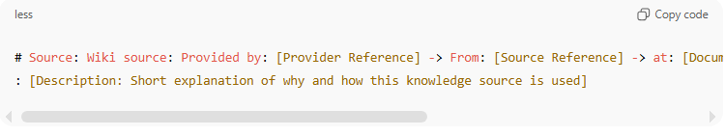
# Source: Wiki source: Provided by: [Provider Reference] ->
From: [Source Reference] -> at: [Document/Section/Page, Position/Heading, “Starting words...Ending words”] on [MM/DD/YYYY]
: [Description: Short explanation of why and how this
knowledge source is used]
Example 1
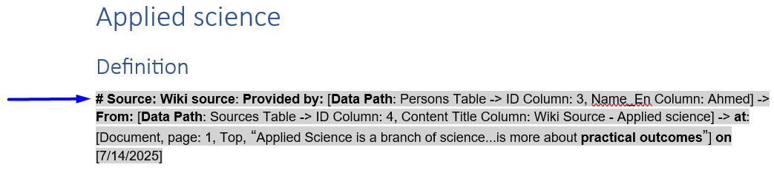
# Source: Wiki source: Provided by: [Data Path: Persons Table -> ID Column: 3, Name_En Column: Ahmed] -> From: [Data Path: Sources Table -> ID Column: 4, Content Title Column: Wiki Source - Applied science] -> at: [Document, page: 1, Top, “Applied Science is a branch of science...is more about practical outcomes”] on [7/14/2025]

Example 2
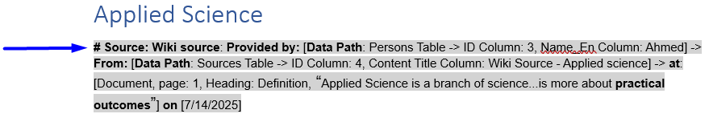
# Source: Wiki source: Provided by: [Data Path: Persons Table -> ID Column: 3, Name_En Column: Ahmed] -> From: [Data Path: Sources Table -> ID Column: 4, Content Title Column: Wiki Source - Applied science] -> at: [Document, page: 1, Heading: Definition, “Applied Science is a branch of science...is more about practical outcomes”] on [7/14/2025]

2-Academic source
# Source: Person Source: Provided by: [Data Path: Persons Table -> ID Column: 1, Name_En Column: Motasem Essam] Written by: [Data Path: Persons Table -> ID Column: 1, Name_En Column: Motasem Essam] on [7/14/2025]
Description
This source Used when the knowledge block is derived from more than one reference (e.g., documents, videos, articles).
Each contributing source is recorded to show how multiple inputs collectively formed the knowledge, ensuring transparency and traceability.
Syntax Format
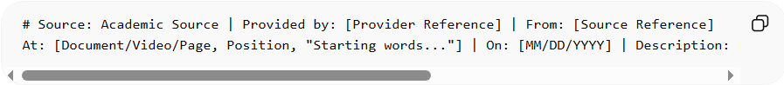
# Source: Academic Source | Provided by: [Provider Reference] | From: [Source Reference]
At: [Document/Video/Page, Position, "Starting words..."] | On: [MM/DD/YYYY] | Description: [Short explanation of why and how this knowledge source is used]
Example - Document
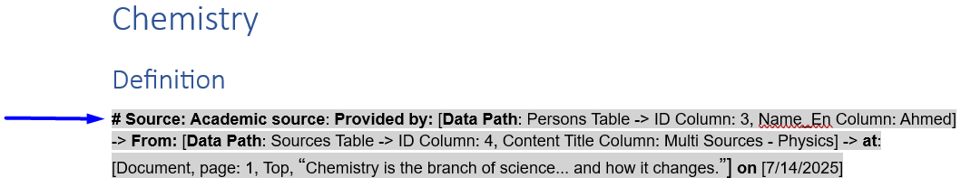
# Source: Academic source: Provided by: [Data Path: Persons Table -> ID Column: 3, Name_En Column: Ahmed] -> From: [Data Path: Sources Table -> ID Column: 4, Content Title Column: Multi Sources - Physics] -> at: [Document, page: 1, Top, “Chemistry is the branch of science... and how it changes.”] on [7/14/2025]

3-Multi sources
# Source: Person Source: Provided by: [Data Path: Persons Table -> ID Column: 1, Name_En Column: Motasem Essam] Written by: [Data Path: Persons Table -> ID Column: 1, Name_En Column: Motasem Essam] on [7/14/2025]
Description
This source Used when the knowledge block is derived from more than one reference (e.g., documents, videos, articles).
Each contributing source is recorded to show how multiple inputs collectively formed the knowledge, ensuring transparency and traceability.
Syntax Format
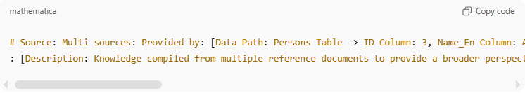
# Source: Multi sources: Provided by: [Provider Reference] -> From: [Source Reference] -> at: [Document/Video/Page, Position, “Starting words....”] on [MM/DD/YYYY]
: [Description: Short explanation of why and how this
knowledge source is used]

Example - Document
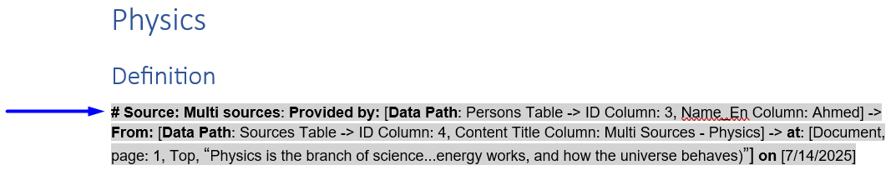
# Source: Multi sources: Provided by: [Data Path: Persons Table -> ID Column: 3, Name_En Column: Ahmed] -> From: [Data Path: Sources Table -> ID Column: 4, Content Title Column: Multi Sources - Physics] -> at: [Document, page: 1, Top, “Physics is the branch of science...energy works, and how the universe behaves)”] on [7/14/2025]

Example - Video
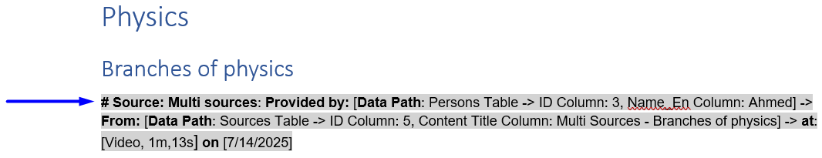
# Source: Multi sources: Provided by: [Data Path: Persons Table -> ID Column: 3, Name_En Column: Ahmed] -> From: [Data Path: Sources Table -> ID Column: 5, Content Title Column: Multi Sources - Branches of physics] -> at: [Video, 1m,13s] on [7/14/2025]

4-AI Source
# Source: Person Source: Provided by: [Data Path: Persons Table -> ID Column: 1, Name_En Column: Motasem Essam] Written by: [Data Path: Persons Table -> ID Column: 1, Name_En Column: Motasem Essam] on [7/14/2025]
Description
This source Used when the knowledge block is generated or explained by an AI system (e.g., ChatGPT).
This record ensures transparency, by identifying the AI model, provider, and date of generation, clarifying that the content is AI-assisted rather than directly human-authored.
Syntax Format
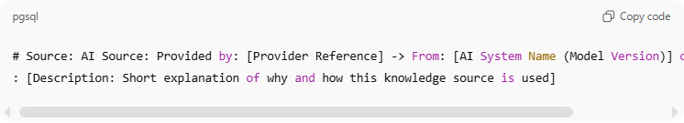
# Source: AI Source: Provided by: [Provider Reference] -> From: [AI System Name (Model Version)] on [MM/DD/YYYY]
: [Description: Short explanation of why and how this knowledge source is used]

Example
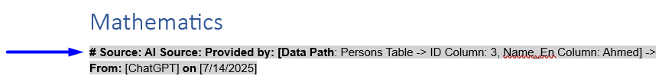
# Source: AI Source: Provided by: [Data Path: Persons Table -> ID Column: 3, Name_En Column: Ahmed] -> From: [ChatGPT] on [7/14/2025]

5-Self-created Source
# Source: Person Source: Provided by: [Data Path: Persons Table -> ID Column: 1, Name_En Column: Motasem Essam] Written by: [Data Path: Persons Table -> ID Column: 1, Name_En Column: Motasem Essam] on [7/14/2025]
Description
This source Used when the knowledge originates from personal work or external persons not in the system—such as notes, experiments, observations, or original insights.
Although it may integrate information from other references, the content represents original intellectual effort from a person outside the internal system, ensuring traceability and clear attribution.
Syntax Format
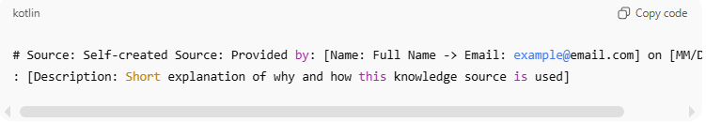
# Source: Self-created Source: Provided by: [Name: Full Name -> Email: example@email.com] on [MM/DD/YYYY]
: [Description: Short explanation of why and how this knowledge source is used]

Example
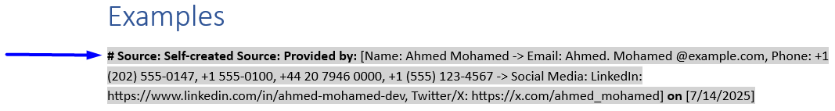
# Source: Self-created Source: Provided by: [Name: Ahmed Mohamed -> Email: Ahmed. Mohamed @example.com, Phone: +1 (202) 555-0147, +1 555-0100, +44 20 7946 0000, +1 (555) 123-4567 -> Social Media: LinkedIn: https://www.linkedin.com/in/ahmed-mohamed-dev, Twitter/X: https://x.com/ahmed_mohamed] on [7/14/2025]
or
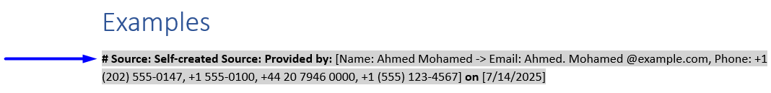
# Source: Self-created Source: Provided by: [Name: Ahmed Mohamed -> Email: Ahmed. Mohamed @example.com, Phone: +1 (202) 555-0147, +1 555-0100, +44 20 7946 0000, +1 (555) 123-4567] on [7/14/2025]
or
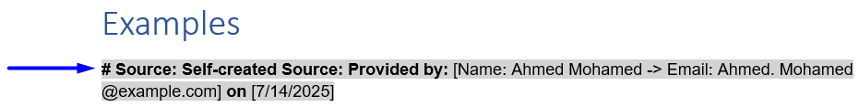
# Source: Self-created Source: Provided by: [Name: Ahmed Mohamed -> Email: Ahmed. Mohamed @example.com] on [7/14/2025]

or
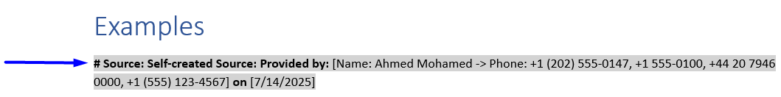
# Source: Self-created Source: Provided by: [Name: Ahmed Mohamed -> Phone: +1 (202) 555-0147, +1 555-0100, +44 20 7946 0000, +1 (555) 123-4567] on [7/14/2025]

or
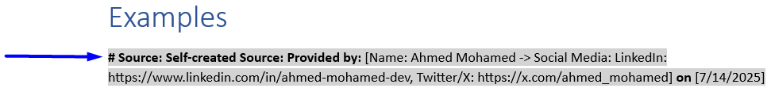
# Source: Self-created Source: Provided by: [Name: Ahmed Mohamed -> Social Media: LinkedIn: https://www.linkedin.com/in/ahmed-mohamed-dev, Twitter/X: https://x.com/ahmed_mohamed] on [7/14/2025]

6-Screenshots Source
# Source: Person Source: Provided by: [Data Path: Persons Table -> ID Column: 1, Name_En Column: Motasem Essam] Written by: [Data Path: Persons Table -> ID Column: 1, Name_En Column: Motasem Essam] on [7/14/2025]
Description
This source Used when the knowledge is captured visually via screenshots to preserve exact formatting, layout, tables, symbols, or images.
This record specifies the tool, platform, and origin, ensuring that the captured information remains verifiable and reproducible, particularly when text-based formats cannot preserve complex structures.
Syntax Format
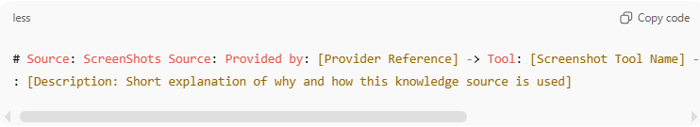
# Source: ScreenShots Source: Provided by: [Provider Reference] -> Tool: [Screenshot Tool Name] -> From: [Operating System or Site: Name] on [MM/DD/YYYY]
: [Description: Short explanation of why and how this knowledge source is used]
Example 1
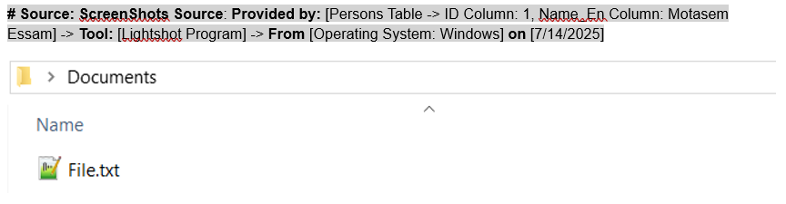
# Source: ScreenShots Source: Provided by: [Persons Table -> ID Column: 1, Name_En Column: Motasem Essam] -> Tool: [Lightshot Program] -> From [Operating System: Windows] on [7/14/2025]

Example 2
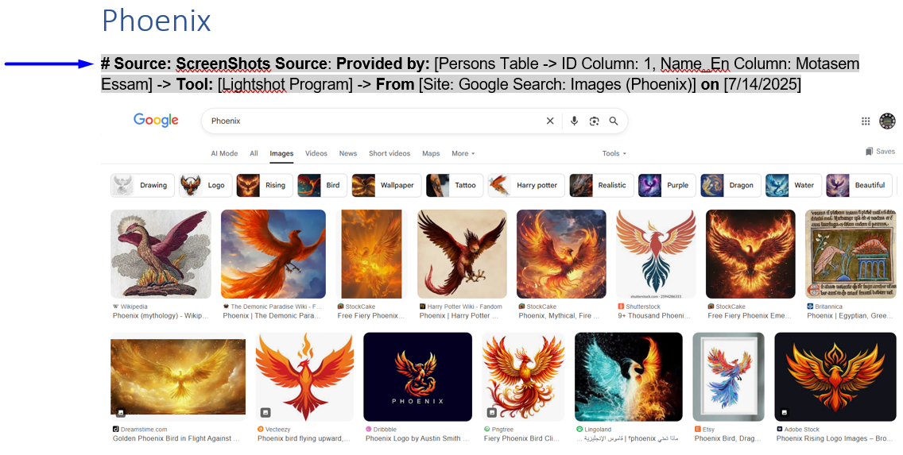
# Source: ScreenShots Source: Provided by: [Persons Table -> ID Column: 1, Name_En Column: Motasem Essam] -> Tool: [Lightshot Program] -> From [Site: Google Search: Images (Phoenix)] on [7/14/2025]

7-Person Source
# Source: Person Source: Provided by: [Data Path: Persons Table -> ID Column: 1, Name_En Column: Motasem Essam] Written by: [Data Path: Persons Table -> ID Column: 1, Name_En Column: Motasem Essam] on [7/14/2025]
Description
This source Used when the knowledge comes directly from a persons already in the system.
This ensures accountability, proper attribution, and traceability. The record distinguishes:
- Provided by → the original knowledge owner within the system
- Written by → the person responsible for recording or transferring the knowledge

6.1-Single Person Source
# Source: Person Source: Provided by: [Data Path: Persons Table -> ID Column: 1, Name_En Column: Motasem Essam] Written by: [Data Path: Persons Table -> ID Column: 1, Name_En Column: Motasem Essam] on [7/14/2025]
Description
Used when the knowledge originates from one identifiable person inside the system.
This ensures clear ownership, accountability, and traceability.

Syntax Format
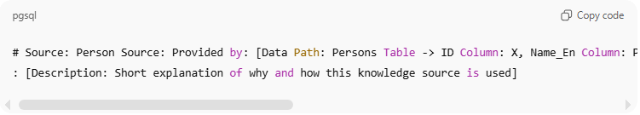
# Source: Person Source: Provided by: [Data Path: Persons Table -> ID Column: X, Name_En Column: Provider Name] -> Written by: [Data Path: Persons Table -> ID Column: Y, Name_En Column: Writer Name] on [MM/DD/YYYY]
: [Description: Short explanation of why and how this knowledge source is used]

Example
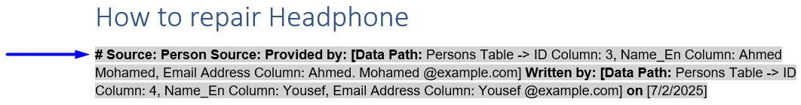
# Source: Person Source: Provided by: [Data Path: Persons Table -> ID Column: 3, Name_En Column: Ahmed Mohamed, Email Address Column: Ahmed. Mohamed @example.com] Written by: [Data Path: Persons Table -> ID Column: 4, Name_En Column: Yousef, Email Address Column: Yousef @example.com] on [7/2/2025]

Or
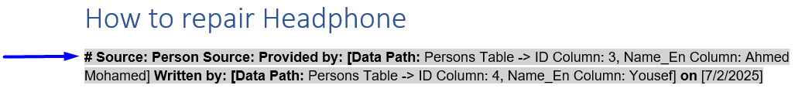
# Source: Person Source: Provided by: [Data Path: Persons Table -> ID Column: 3, Name_En Column: Ahmed Mohamed] Written by: [Data Path: Persons Table -> ID Column: 4, Name_En Column: Yousef] on [7/2/2025]

6.2-Group of Persons Source
# Source: Person Source: Provided by: [Data Path: Persons Table -> ID Column: 1, Name_En Column: Motasem Essam] Written by: [Data Path: Persons Table -> ID Column: 1, Name_En Column: Motasem Essam] on [7/14/2025]
Description
Used when the knowledge originates from multiple persons acting as a group (meeting, workshop, class, team discussion).
Ownership is collective, but traceability remains individual and explicit.
Syntax Format
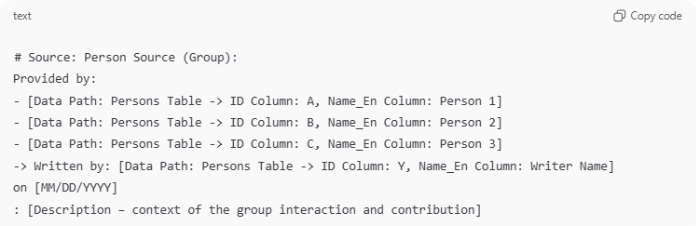
# Source: Person Source (Group):
Provided by:
- [Data Path: Persons Table -> ID Column: A, Name_En Column: Person 1]
- [Data Path: Persons Table -> ID Column: B, Name_En Column: Person 2]
- [Data Path: Persons Table -> ID Column: C, Name_En Column: Person 3]
-> Written by: [Data Path: Persons Table -> ID Column: Y, Name_En Column: Writer Name]
on [MM/DD/YYYY]
: [Description – context of the group interaction and contribution]

Example
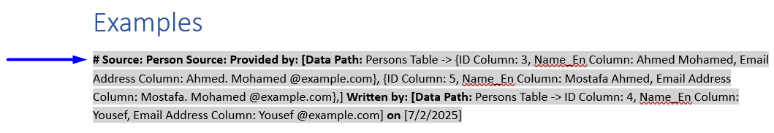
# Source: Person Source: Provided by: [Data Path: Persons Table -> {ID Column: 3, Name_En Column: Ahmed Mohamed, Email Address Column: Ahmed. Mohamed @example.com}, {ID Column: 5, Name_En Column: Mostafa Ahmed, Email Address Column: Mostafa. Mohamed @example.com},] Written by: [Data Path: Persons Table -> ID Column: 4, Name_En Column: Yousef, Email Address Column: Yousef @example.com] on [7/2/2025]

or
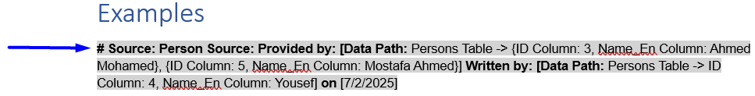
# Source: Person Source: Provided by: [Data Path: Persons Table -> {ID Column: 3, Name_En Column: Ahmed Mohamed}, {ID Column: 5, Name_En Column: Mostafa Ahmed}] Written by: [Data Path: Persons Table -> ID Column: 4, Name_En Column: Yousef] on [7/2/2025]

8-Book Source
# Source: Person Source: Provided by: [Data Path: Persons Table -> ID Column: 1, Name_En Column: Motasem Essam] Written by: [Data Path: Persons Table -> ID Column: 1, Name_En Column: Motasem Essam] on [7/14/2025]
Description
This source Used when the knowledge block is extracted from a published book.
This record specifies the exact book, page, and block or section to enable precise academic or professional referencing, ensuring that the source can be traced and verified.

Syntax Format
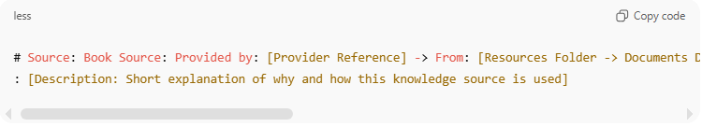
# Source: Book Source: Provided by: [Provider Reference] -> From: [Resources Folder -> Documents Database -> Documents Table -> ID Column: X | Blocks Table -> ID Column: Y] -> at: [page: X, Position, “Starting words....”] on [MM/DD/YYYY]
: [Description: Short explanation of why and how this knowledge source is used]

Example
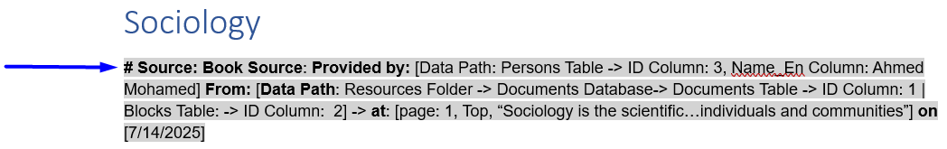
# Source: Book Source: Provided by: [Data Path: Persons Table -> ID Column: 3, Name_En Column: Ahmed Mohamed] From: [Data Path: Resources Folder -> Documents Database-> Documents Table -> ID Column: 1 | Blocks Table: -> ID Column: 2] -> at: [page: 1, Top, “Sociology is the scientific…individuals and communities”] on [7/14/2025]

9-Table Source
# Source: Person Source: Provided by: [Data Path: Persons Table -> ID Column: 1, Name_En Column: Motasem Essam] Written by: [Data Path: Persons Table -> ID Column: 1, Name_En Column: Motasem Essam] on [7/14/2025]
Description
This source Used when the knowledge originates from structured data stored in system tables or databases. This record connects the knowledge block to a specific table and ID, ensuring data integrity, traceability, and the ability to update content if the underlying table changes.
Syntax Format
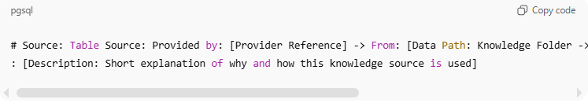
# Source: Table Source: Provided by: [Provider Reference] -> From: [Data Path: Knowledge Folder -> Knowledge Database -> Table Name -> ID: X] on [MM/DD/YYYY]
: [Description: Short explanation of why and how this knowledge source is used]

Example
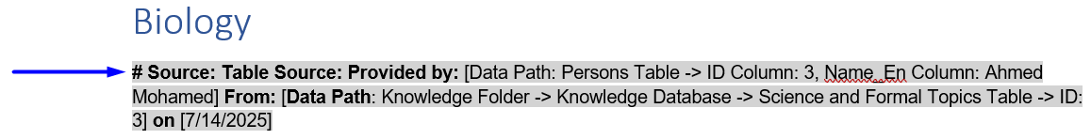
# Source: Table Source: Provided by: [Data Path: Persons Table -> ID Column: 3, Name_En Column: Ahmed Mohamed] From: [Data Path: Knowledge Folder -> Knowledge Database -> Science and Formal Topics Table -> ID: 3] on [7/14/2025]

10-Processing Source
# Source: Person Source: Provided by: [Data Path: Persons Table -> ID Column: 1, Name_En Column: Motasem Essam] Written by: [Data Path: Persons Table -> ID Column: 1, Name_En Column: Motasem Essam] on [7/14/2025]
Description
This source is used to record any transformation, transfer, or restructuring of knowledge from one source record to another, regardless of how many times this occurs. It preserves full traceability, showing origin, intermediate, and final sources in a single, continuous record.

Syntax Format
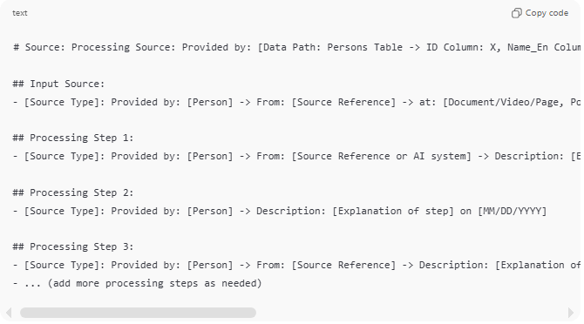
# Source: Processing Source: Provided by: [Data Path: Persons Table -> ID Column: X, Name_En Column: Person Name] -> Description: “[Brief description of the overall processing or consolidation task]” on [MM/DD/YYYY]

## Input Source:
- [Source Type]: Provided by: [Person] -> From: [Source Reference] -> at: [Document/Video/Page, Position, “Starting words....”] -> Description: [Short explanation of why and how this knowledge source is used] on [MM/DD/YYYY]

## Processing Step 1:
- [Source Type]: Provided by: [Person] -> From: [Source Reference or AI system] -> Description: [Explanation of what was done in this step] on [MM/DD/YYYY]

## Processing Step 2:
- [Source Type]: Provided by: [Person] -> Description: [Explanation of step] on [MM/DD/YYYY]

## Processing Step 3:
- [Source Type]: Provided by: [Person] -> From: [Source Reference] -> Description: [Explanation of step] on [MM/DD/YYYY]
- ... (add more processing steps as needed)

Example
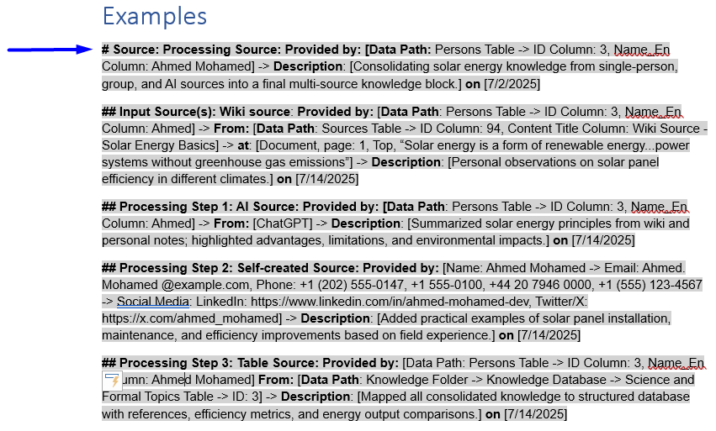
# Source: Processing Source: Provided by: [Data Path: Persons Table -> ID Column: 3, Name_En Column: Ahmed Mohamed] -> Description: [Consolidating solar energy knowledge from single-person, group, and AI sources into a final multi-source knowledge block.] on [7/2/2025]
## Input Source(s): Wiki source: Provided by: [Data Path: Persons Table -> ID Column: 3, Name_En Column: Ahmed] -> From: [Data Path: Sources Table -> ID Column: 94, Content Title Column: Wiki Source - Solar Energy Basics] -> at: [Document, page: 1, Top, “Solar energy is a form of renewable energy...power systems without greenhouse gas emissions”] -> Description: [Personal observations on solar panel efficiency in different climates.] on [7/14/2025]
## Processing Step 1: AI Source: Provided by: [Data Path: Persons Table -> ID Column: 3, Name_En Column: Ahmed] -> From: [ChatGPT] -> Description: [Summarized solar energy principles from wiki and personal notes; highlighted advantages, limitations, and environmental impacts.] on [7/14/2025]
## Processing Step 2: Self-created Source: Provided by: [Name: Ahmed Mohamed -> Email: Ahmed. Mohamed @example.com, Phone: +1 (202) 555-0147, +1 555-0100, +44 20 7946 0000, +1 (555) 123-4567 -> Social Media: LinkedIn: https://www.linkedin.com/in/ahmed-mohamed-dev, Twitter/X: https://x.com/ahmed_mohamed] -> Description: [Added practical examples of solar panel installation, maintenance, and efficiency improvements based on field experience.] on [7/14/2025]
## Processing Step 3: Table Source: Provided by: [Data Path: Persons Table -> ID Column: 3, Name_En Column: Ahmed Mohamed] From: [Data Path: Knowledge Folder -> Knowledge Database -> Science and Formal Topics Table -> ID: 3] -> Description: [Mapped all consolidated knowledge to structured database with references, efficiency metrics, and energy output comparisons.] on [7/14/2025]

3-Book/Documents Chapters Mapping

3.1-Chapter Structure
# Source: AI Source: Provided by: [Data Path: Persons Table -> ID Column: 1, Name_En Column: Motasem Essam] -> From: [ChatGPT] on [7/14/2025]
The book is organized into files.
- Each file represents a chapter (e.g., Chapter 2)
- Each chapter is divided as follows:
  - By default: Each chapter is organized into headings and subheadings such as: 2.1, 2.2, 2.2.1, 2.3, etc, with each heading containing all the content in the book, divided into blocks labeled with #
Example:
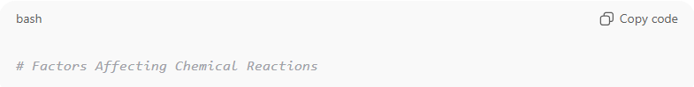
# Factors Affecting Chemical Reactions
  - If the chapter contains additional items such as images, other resources, or exercises, the chapter will be stored in a folder containing three files/subfolders:
    - Content → Main textual content divided into headings, subheadings and blocks.
    - Resources → Includes pages (start to end), outline headings, figures, descriptions, social issues, additional reading, and other supplementary materials.
    - Answers to Questions & Exercises → Solutions or guidance for any questions and exercises in the chapter.
- Each chapter Content is divided into headings and subheadings,
- Each heading or subheading contains all the content in the book, divided into one or more blocks, each labeled with a descriptive name using # symbols.
- Important terms or phrases inside any block may be written in bold to highlight key concepts.
- A heading or subheading may contain multiple blocks, and each block should be indicated with an asterisk (*) before the text.
- A block (or multiple blocks together) can be sent to AI for description or elaboration. The resulting AI-generated description is added immediately after the block(s) it describes.
Example:
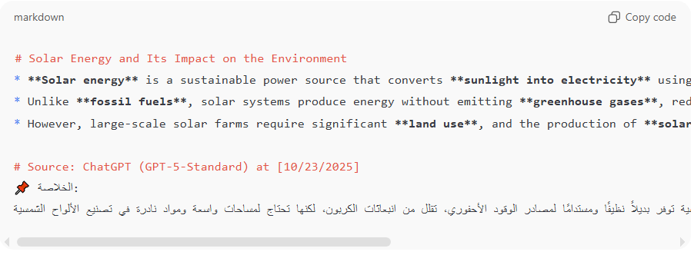
# Solar Energy and Its Impact on the Environment
* **Solar energy** is a sustainable power source that converts **sunlight into electricity** using **photovoltaic cells**.
* Unlike **fossil fuels**, solar systems produce energy without emitting **greenhouse gases**, reducing the overall **carbon footprint**.
* However, large-scale solar farms require significant **land use**, and the production of **solar panels** involves **rare materials** that must be managed responsibly.
# Source: AI Source: Provided by: [Data Path: Persons Table -> ID Column: 1, Name_En Column: Motasem Essam] -> From: [ChatGPT] on [10/23/2025]
📌 الخلاصة:
الطاقة الشمسية توفر بديلاً نظيفًا ومستدامًا لمصادر الوقود الأحفوري، تقلل من انبعاثات الكربون، لكنها تحتاج لمساحات واسعة ومواد نادرة في تصنيع الألواح الشمسية.

- In addition to normal blocks that begin with a single asterisk (*), a double asterisk (**) may be used to indicate a sub-block or quoted / extended text within the same heading. A ** block should follow immediately after the * block it belongs to (no blank line). The content in ** blocks can include bold text for highlighting important concepts or phrases, just like normal blocks.
Example:
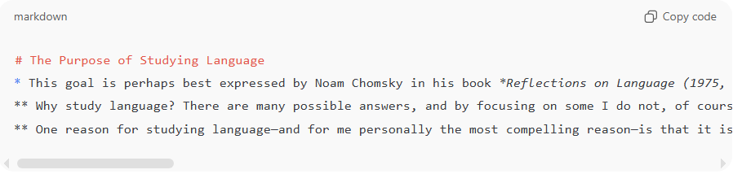
# The Purpose of Studying Language
* This goal is perhaps best expressed by Noam Chomsky in his book *Reflections on Language (1975, 3–4)*:
** Why study language? There are many possible answers, and by focusing on some I do not, of course, mean to disparage others or question their legitimacy. One may, for example, simply be fascinated by the elements of language in themselves and want to discover their order and arrangement, their origin in history or in the individual, or the ways in which they are used in thought, in science or in art, or in normal social interchange.
** One reason for studying language—and for me personally the most compelling reason—is that it is tempting to regard language, in the traditional phrase, as *“a mirror of mind.”* I do not mean by this simply that the concepts expressed and distinctions developed in normal language use give us insight into the patterns of thought and the world of “common sense” constructed by the human mind.

3.2-Additional Files and Folders
# Source: AI Source: Provided by: [Data Path: Persons Table -> ID Column: 1, Name_En Column: Motasem Essam] -> From: [ChatGPT] on [7/14/2025]
In addition to chapters, the book may include supplementary files or folders that appear before or after the main chapters. These can be stored as separate files or folders (depending on whether they include extra materials such as images or data).
Front Matter (before chapters):
- Cover Page
- Title Page
- ISBN 9780262013758
- Contents
- Acknowledgments
- Note to the Teacher
Back Matter (after chapters):
- Appendix – The Written Representation of Language
- Glossary
- Index
These sections follow the same file and folder naming conventions as the chapters and can be numbered or ordered for consistency (e.g., 01_Cover_Page, 02_Title_Page, 03_ISBN_9780262013758, …, 99_Appendix, 100_Glossary, 101_Index).

✅ Note:
Front Matter and Back Matter folders are optional.
A book may consist of only Content_Matter Regardless of the organization method, the sequence of materials (Front → Content → Back) should always follow the book’s natural order.

3.3-Folder Organization
# Source: AI Source: Provided by: [Data Path: Persons Table -> ID Column: 1, Name_En Column: Motasem Essam] -> From: [ChatGPT] on [7/14/2025]
The overall book structure can be organized in one of two ways:
- Option A – Three Main Folders
  - Front Matter → Contains all pre-chapter materials (Cover Page, Title Page, etc.)
  - Content Matter → Contains all chapter files and chapter folders
  - Back Matter → Contains all post-chapter materials (Appendix, Glossary, Index)
Example:
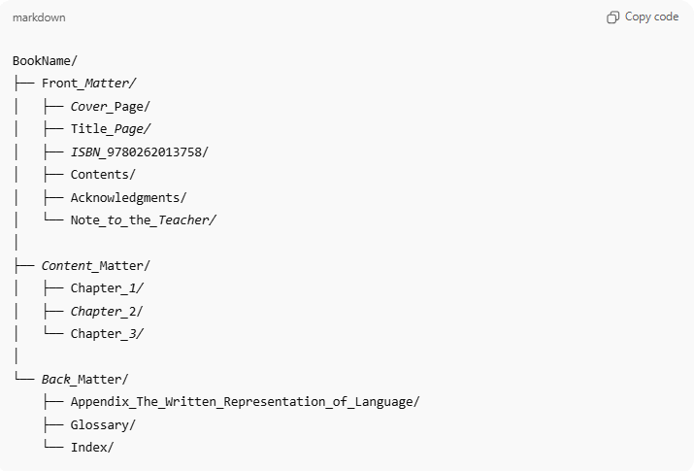
BookName/
├── Front_Matter/
│ ├── Cover_Page/
│ ├── Title_Page/
│ ├── ISBN_9780262013758/
│ ├── Contents/
│ ├── Acknowledgments/
│ └── Note_to_the_Teacher/
│
├── Content_Matter/
│ ├── Chapter_1/
│ ├── Chapter_2/
│ └── Chapter_3/
│
└── Back_Matter/
├── Appendix_The_Written_Representation_of_Language/
├── Glossary/
└── Index/

Option B – Single Folder with Ordered Files
- All items (Front Matter, Chapters, Back Matter) are stored in a single folder, following their correct order in the book.
Example:
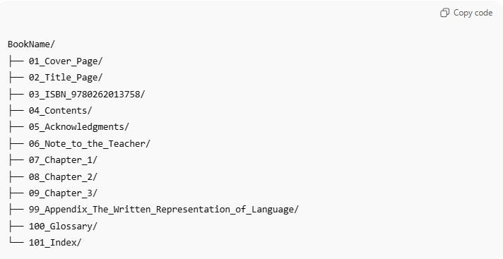
BookName/
├── 01_Cover_Page/
├── 02_Title_Page/
├── 03_ISBN_9780262013758/
├── 04_Contents/
├── 05_Acknowledgments/
├── 06_Note_to_the_Teacher/
├── 07_Chapter_1/
├── 08_Chapter_2/
├── 09_Chapter_3/
├── 99_Appendix_The_Written_Representation_of_Language/
├── 100_Glossary/
└── 101_Index/

4-Video Knowledge Mapping

1. File Structure
# Source: AI Source: Provided by: [Data Path: Persons Table -> ID Column: 1, Name_En Column: Motasem Essam] -> From: [ChatGPT] on [7/14/2025]
Each video should have two linked files:
- Video File (.mp4) — the original content
- Mapping File (.docx / .md / .txt) — your structured notes
Example:
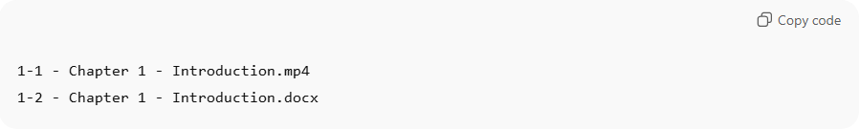
1-1 - Chapter 1 - Introduction.mp4
1-2 - Chapter 1 - Introduction.docx
- The numeric prefix (1-1, 1-2) links the two files.
- Both must share the same base name (Chapter 1 - Introduction).
- The mapping file documents what happens inside the video.

2. Section Format
# Source: AI Source: Provided by: [Data Path: Persons Table -> ID Column: 1, Name_En Column: Motasem Essam] -> From: [ChatGPT] on [7/14/2025]
Each heading or subheading in the mapping file represents a key concept or moment in the video.
Before each heading, write a bold timestamp reference line showing where that content appears in the video.
🟨 Bold Rule:
The entire timestamp line (e.g., “Chapter 2_part 1 - start at 1:36”) must be bold — not symbols or Markdown (**), but real bold formatting as in Word or text editors.
Format Example:
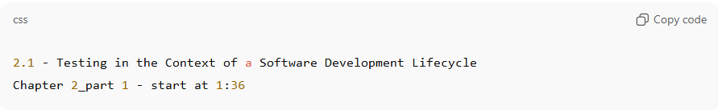
2.1 - Testing in the Context of a Software Development Lifecycle
Chapter 2_part 1 - start at 1:36
Then, beneath it, include one or more of the following elements (as you choose):
- Description — short explanation or summary of what happens in that part
- Screenshot — filename or image reference (optional)
- Subtitle extract — one or more lines directly from the video
- Notes — your own insights, commentary, or context
Example:
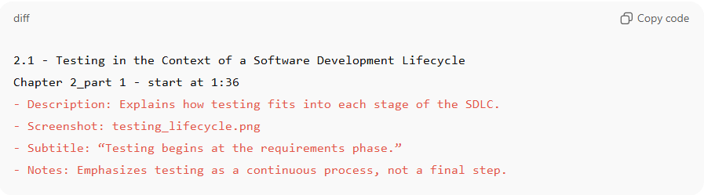
2.1 - Testing in the Context of a Software Development Lifecycle
Chapter 2_part 1 - start at 1:36
- Description: Explains how testing fits into each stage of the SDLC.
- Screenshot: testing_lifecycle.png
- Subtitle: “Testing begins at the requirements phase.”
- Notes: Emphasizes testing as a continuous process, not a final step.

🟫 Empty Content Rule:
A section may have no content even if information is available.
Leaving a section empty is acceptable and does not require a placeholder or explanation — this simply means no details are added for that part.

3. Section Numbering & Hierarchy
# Source: AI Source: Provided by: [Data Path: Persons Table -> ID Column: 1, Name_En Column: Motasem Essam] -> From: [ChatGPT] on [7/14/2025]
Keep your mapping organized using hierarchical numbering that matches the logical flow of the video.
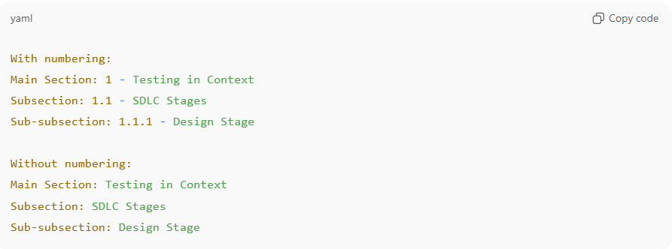
With numbering:
Main Section: 1 - Testing in Context
Subsection: 1.1 - SDLC Stages
Sub-subsection: 1.1.1 - Design Stage

Without numbering:
Main Section: Testing in Context
Subsection: SDLC Stages
Sub-subsection: Design Stage

Each level may include its own bold timestamp line, for example:
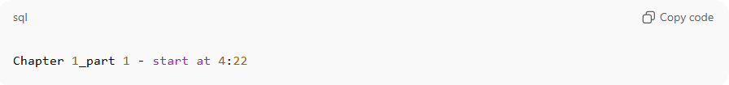
Chapter 1_part 1 - start at 4:22

4. File Naming Rules
# Source: AI Source: Provided by: [Data Path: Persons Table -> ID Column: 1, Name_En Column: Motasem Essam] -> From: [ChatGPT] on [7/14/2025]
Each mapping file uses the same name as the related video, with a .docx extension.
Examples:
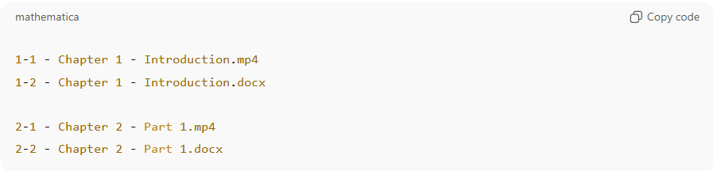
1-1 - Chapter 1 - Introduction.mp4
1-2 - Chapter 1 - Introduction.docx

2-1 - Chapter 2 - Part 1.mp4
2-2 - Chapter 2 - Part 1.docx

5. Flexibility Rule
# Source: AI Source: Provided by: [Data Path: Persons Table -> ID Column: 1, Name_En Column: Motasem Essam] -> From: [ChatGPT] on [7/14/2025]
You can use any combination of the following four detail types:
• Description
• Screenshot
• Subtitle extract
• Notes
No section is required to include all four — or any of them.
Include only what’s valuable, relevant, or appropriate for that part of the video.
It’s also acceptable for a section to remain empty, even if related information is available.
The goal is clarity and traceability, not uniformity.

6. Multi-File Documentation
# Source: AI Source: Provided by: [Data Path: Persons Table -> ID Column: 1, Name_En Column: Motasem Essam] -> From: [ChatGPT] on [7/14/2025]
A single Video Knowledge Mapping document may cover multiple related video files when they belong to the same topic, chapter, or module.
Rules:
- Each video entry must begin with a separate bold timestamp header identifying the video name and starting time.
Example:
Chapter 2_part 1 - start at 0:00
Chapter 2_part 2 - start at 12:45
- You can continue numbering sections sequentially across files — e.g., 2.1, 2.2, 2.3 — even if they come from different videos.
- If the document covers multiple files, include a short note at the top listing all referenced videos:
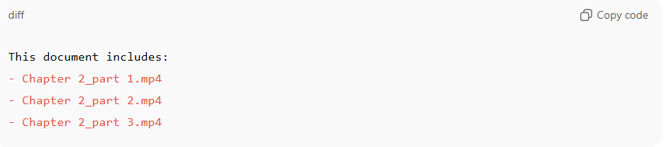This document includes:
- Chapter 2_part 1.mp4
- Chapter 2_part 2.mp4
- Chapter 2_part 3.mp4

- Use clear spacing or horizontal lines (—) between sections from different videos to avoid confusion.

5-Rules for Tables, Complex Symbols, and Lists
# Source: AI Source: Provided by: [Data Path: Persons Table -> ID Column: 1, Name_En Column: Motasem Essam] -> From: [ChatGPT] on [7/14/2025]
Rules for Using Tables, Complex Symbols, and Lists from AI or Other Sources
- Tables
  - When obtaining a table from ChatGPT or any other source, take a screenshot of it.
  - Purpose: Ensure the table’s format, structure, and content are preserved accurately.
- Complex Symbols
  - For formulas, mathematical symbols, or any complex symbols that may not render correctly in text, take a screenshot.
  - Purpose: Avoid errors in displaying equations, special symbols, or non-standard characters.
- Lists (Optional)
  - If a list is optional but comes from AI or other sources, take a screenshot to preserve its structure.
  - Purpose: Maintain readability and formatting.

6-Font Styles for Knowledge Sources

My Sources File
# Source: AI Source: Provided by: [Data Path: Persons Table -> ID Column: 1, Name_En Column: Motasem Essam] -> From: [ChatGPT] on [7/14/2025]
🔹 Recommended Usage in Your Document
- Headings (e.g., "Knowledge Sources") → Use a clean sans-serif like Roboto (Regular or Bold) or Calibri.
- Content (lists of sources, paths, rules, templates) → Use Roboto Mono, 11 pt or 12 pt.
- Example:
Knowledge Sources (Heading in Roboto Bold, 12 pt):
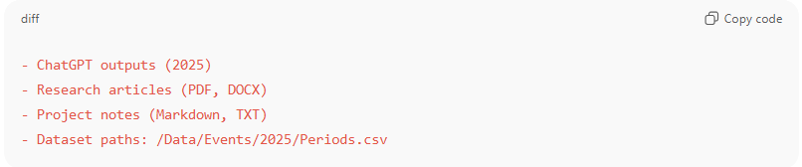
- ChatGPT outputs (2025)
- Research articles (PDF, DOCX)
- Project notes (Markdown, TXT)
- Dataset paths: /Data/Events/2025/Periods.csv

Book/Documents Chapters
# Source: AI Source: Provided by: [Data Path: Persons Table -> ID Column: 1, Name_En Column: Motasem Essam] -> From: [ChatGPT] on [7/14/2025]
- Headings (e.g., "Knowledge Sources") → Use a serif font like Garamond or Times New Roman, size 11–12 pt for readability.
- Content (lists of sources, paths, rules, templates) → Use Roboto Mono, 11 pt or 12 pt.
- Example:
Knowledge Sources (Heading in Roboto Bold, 12 pt):

Book/Documents Chapters blocks
# Source: AI Source: Provided by: [Data Path: Persons Table -> ID Column: 1, Name_En Column: Motasem Essam] -> From: [ChatGPT] on [7/14/2025]
- Font size: 16 pt
- Font weight: Bold
- Background color: Grey (e.g., Light Gray in Word)
# Factors Affecting Chemical Reactions

